Price testing

Cost model with the new lookup element.

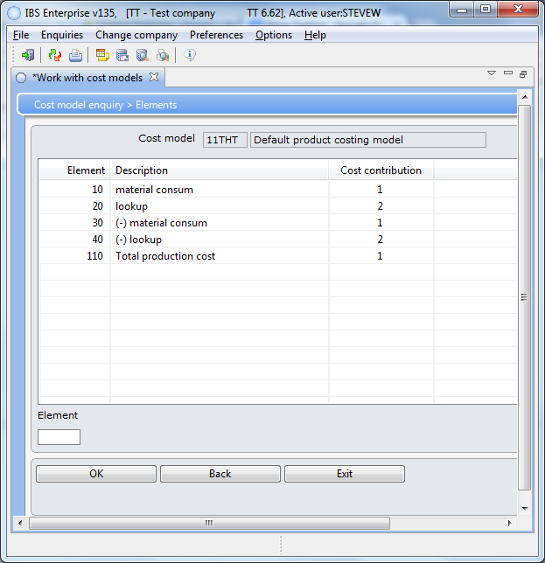For some strange reason you have to add 30 and 40 to subtract the consumption and lookup values. The internal calculation adds them in.

Lookup (20) is an element of the cost model. We can and do use a lookup to retrieve the price we are going to use for a customer.

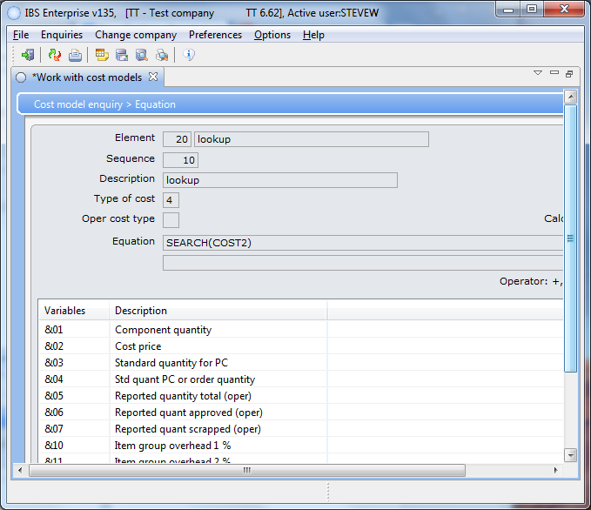The lookup element uses the following:

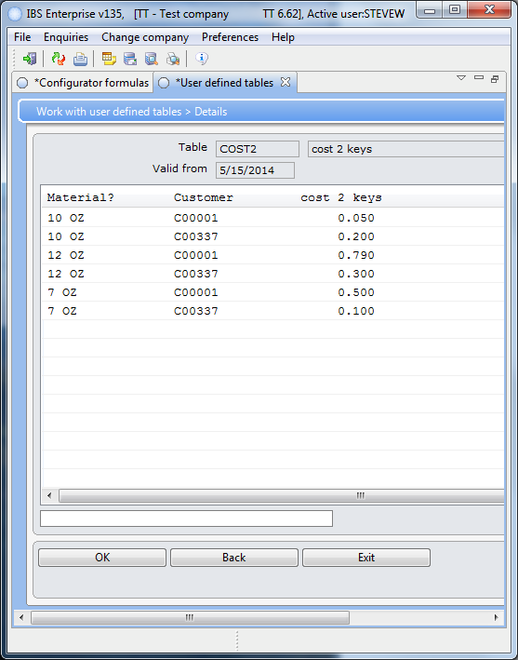

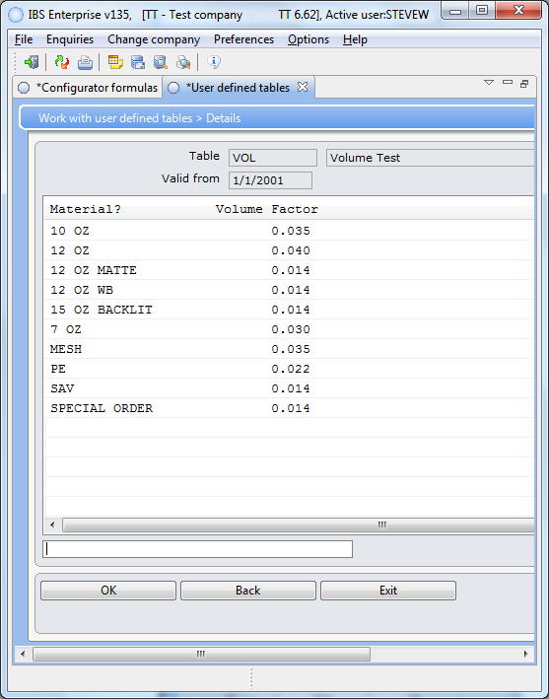The VOL table

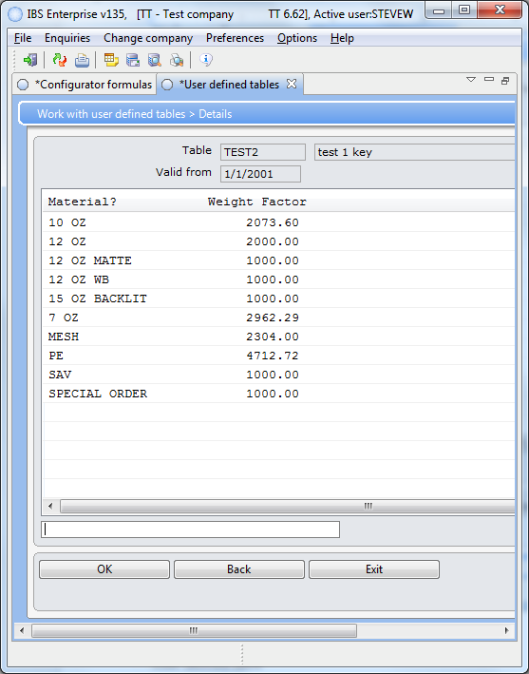The weight table.

C00001

